****

**PERSONAL BUDGET MANAGEMENT SYSTEM**

**A Project Report submitted to the school of ICT Media and Engineering in partial fulfilment of the requirements for the award of the Diploma in information technology, Zetech University.**

**AUGUST 2025**

# **DECLARATION**

I, **[Your Name], Reg. No.**, declared that this **Personal Budget Management System** was my original work, submitted in partial fulfillment of the requirements for the IT Diploma Award.

# **DEDICATION**

This work was dedicated to my family, friends, and all who supported and encouraged me through the project journey.

# **ABSTRACT**

This study presented the design, development, and evaluation of a **Personal Budget Management System** tailored for Kenyan youth. It aimed to address gaps in expense tracking and budgeting within mobile money ecosystems. The system was built using PHP, MySQL, and modern CSS and offered features including secure user authentication, income/expense recording, category-based budget setting with threshold alerts, financial dashboards, and an admin panel for user and system setting management. A survey of university students was conducted to assess usability and impact. Results showed improved user awareness, effective budget discipline, and high satisfaction with the alert-driven budgeting approach.

# **ACKNOWLEDGMENT**

I was deeply thankful to my supervisor for guidance, to peers and respondents who tested the system, and to my family for their unwavering support.

# **TABLE OF CONTENTS**

Table of Contents

[1](#_Toc204599294)

[**PERSONAL BUDGET MANAGEMENT SYSTEM** 1](#_Toc204599295)

[**A Project Report submitted to the school of ICT Media and Engineering in partial fulfilment of the requirements for the award of the Diploma in information technology, Zetech University.** 1](#_Toc204599296)

[**AUGUST 2025** 1](#_Toc204599297)

[**DECLARATION** 2](#_Toc204599298)

[**DEDICATION** 3](#_Toc204599299)

[**ABSTRACT** 4](#_Toc204599300)

[**ACKNOWLEDGMENT** 5](#_Toc204599301)

[**TABLE OF CONTENTS** 6](#_Toc204599302)

[**CHAPTER 1 INTRODUCTION** 6](#_Toc204599303)

[**1.1 Background of the Problem** 6](#_Toc204599304)

[**1.2 Problem Statement** 6](#_Toc204599305)

[**1.3 Description of the Current System** 6](#_Toc204599306)

[**1.4 How the Existing System Worked** 6](#_Toc204599307)

[**1.4.1 Weaknesses of the Current System** 6](#_Toc204599308)

[**1.4.2 Proposed Solution** 6](#_Toc204599309)

[**1.4.3 Justification** 7](#_Toc204599310)

[**1.4.4 Objectives of the Study** 7](#_Toc204599311)

[**1.4.5 Justification of the Study** 7](#_Toc204599312)

[**1.4.6 Scope of the Study** 7](#_Toc204599313)

[**CHAPTER 2 LITERATURE REVIEW** 8](#_Toc204599314)

[**2.1 Introduction** 8](#_Toc204599315)

[**2.2 Budgeting Theory & Personal Finance** 8](#_Toc204599316)

[**2.3 Existing Budgeting Applications** 8](#_Toc204599317)

[**2.4 Local Innovations & Gaps in Kenya** 8](#_Toc204599318)

[**2.5 Research Gaps** 8](#_Toc204599319)

[**2.6 Summary** 8](#_Toc204599320)

[**CHAPTER 3 RESEARCH METHODOLOGY** 9](#_Toc204599321)

[**3.1 Conceptual Framework & Methodology** 9](#_Toc204599322)

[**3.2 Survey and Interview Design** 9](#_Toc204599323)

[**3.2.1 Population and Sampling** 9](#_Toc204599324)

[**3.2.2 Survey Instruments** 9](#_Toc204599325)

[**3.3 Data Analysis & Interpretation** 9](#_Toc204599326)

[**3.4 Ethical Considerations** 9](#_Toc204599327)

[**3.5 Summary of Methodology Used** 9](#_Toc204599328)

[**CHAPTER 4 SYSTEM ANALYSIS** 10](#_Toc204599329)

[**4.1 Preliminary Findings** 10](#_Toc204599330)

[**4.2 System Design** 10](#_Toc204599331)

[**4.2.1 Existing System Flow** 10](#_Toc204599332)

[**4.2.2 Prototype System Design** 10](#_Toc204599333)

[12](#_Toc204599334)

[**CHAPTER 5 SYSTEM IMPLEMENTATION AND TESTING** 14](#_Toc204599335)

[**5.0 Software Testing Strategy** 14](#_Toc204599336)

[**5.1 Unit Testing** 14](#_Toc204599337)

[**5.2 Integration Testing** 14](#_Toc204599338)

[**5.3 Usability Testing** 14](#_Toc204599339)

[**5.4 Regression Testing** 14](#_Toc204599340)

[**CHAPTER 6 CONCLUSION AND RECOMMENDATIONS** 15](#_Toc204599341)

[**Conclusion** 15](#_Toc204599342)

[**Recommendations** 15](#_Toc204599343)

[**Further Studies** 15](#_Toc204599344)

[**APPENDIX 1: SURVEY QUESTIONNAIRE** 16](#_Toc204599345)

[**APPENDIX 2: INTERVIEW GUIDE** 16](#_Toc204599346)

[**REFERENCES** 16](#_Toc204599347)

[**SCREENSHOTS OF SYSTEM** 16](#_Toc204599348)

[**TABLE OF FIGURES** 25](#_Toc204599349)

# **CHAPTER 1 INTRODUCTION**

# **1.1 Background of the Problem**

Kenyan youth heavily relied on mobile money platforms like **M‑Pesa** for financial transactions, yet lacked integrated tools for budgeting or expense monitoring. According to the **FinAccess 2021 Survey**, only 38% of adults actively tracked their expenses, signifying a major gap [UVA Today](https://news.virginia.edu/content/heres-how-build-better-personal-budget?).

# **1.2 Problem Statement**

There was no accessible, local digital solution enabling efficient income and expense management, category-based budgeting, and timely alerts, particularly for entry-level smartphones or limited internet environments.

# **1.3 Description of the Current System**

Users typically relied on manual methods: handwritten logs, spreadsheets, or note-taking. These approaches lacked reminders, analytics, and did not support any automated budgeting process.

# **1.4 How the Existing System Worked**

# **1.4.1 Weaknesses of the Current System**

* High likelihood of manual data entry errors
* Lack of real-time alerts or visual financial summaries
* Inaccessible on low-data or offline scenarios

**1.4.2 Proposed Solution**

The system introduced an **offline-capable PHP/MySQL web application** offering user registration/login, transaction recording (income or expense), budget configuration per category, threshold-based alerting, dashboards, and an administrative backend.

# **1.4.3 Justification**

It delivered affordability, accessibility on low-end devices, and context-specific budgeting categories (e.g. airtime, rent, food), filling gaps not addressed by existing local financial tools like mobile money platforms.

# **1.4.4 Objectives of the Study**

**General Objective:** To empower Kenyan youth with digital tools for improved personal budgeting.  
**Specific Objectives:**

* Enable secure user registration and login
* Facilitate transaction management
* Provide budget alerts when near category thresholds
* Offer dashboard summaries and admin control over users and settings

# **1.4.5 Justification of the Study**

The system supported improved financial literacy and affordably addressed a common pain point among students and young professionals who lacked formal budgeting infrastructure.

# **1.4.6 Scope of the Study**

It included full user and admin functionality, design and testing phases, and was deployed as a PHP/MySQL application, tested with young adults in Nairobi.

# **CHAPTER 2 LITERATURE REVIEW**

# **2.1 Introduction**

This chapter explored budgeting theories and reviewed relevant digital tools.

# **2.2 Budgeting Theory & Personal Finance**

Behavioral finance research showed that personal budgets acted as commitment devices helping manage self-control and expenditure decisions [Wiley Online Library+4ResearchGate+4SSRN+4](https://www.researchgate.net/publication/330817113_A_theory_of_personal_budgeting?). Effective budgeting led to measurable reductions in category spending.

# **2.3 Existing Budgeting Applications**

Many global apps like "You Need a Budget" and "Mint" provided robust dashboards, but often lacked local adaptability or offline features.

# **2.4 Local Innovations & Gaps in Kenya**

While M‑Pesa and other fintech services had wide adoption, they lacked integrated budgeting features, analytics, or threshold alerts.

# **2.5 Research Gaps**

Literature revealed few solutions tailored to youth in developing contexts that combined budgeting controls, offline usability, and category alerts.

# **2.6 Summary**

There was a strong rationale for a low-cost, user-friendly budgeting platform aligned with youth needs and data-limited environments.

# **CHAPTER 3 RESEARCH METHODOLOGY**

# **3.1 Conceptual Framework & Methodology**

A **mixed-methods** approach was adopted.

A **conceptual model** informed system requirements:

user budget usage tracking flow → budget threshold alert → dashboard summary.

# **3.2 Survey and Interview Design**

# **3.2.1 Population and Sampling**

Targeted university students and young professionals in Nairobi (n≈50 responded; 10 participated in interviews).

# **3.2.2 Survey Instruments**

A structured questionnaire assessed budgeting habits, mobile app usage, and financial challenges. Interviews explored user expectations for features.

# **3.3 Data Analysis & Interpretation**

Survey data was analyzed quantitatively (e.g., percent who tracked expenses). Interview data was thematically coded to derive feature priorities—alerts, offline use, ease of entry.

# **3.4 Ethical Considerations**

Informed consent was obtained; anonymity preserved; no personal identifying information was collected.

# **3.5 Summary of Methodology Used**

By combining survey metrics with qualitative user perspectives, system features were validated and prioritized in the development process.

# **CHAPTER 4 SYSTEM ANALYSIS**

# **4.1 Preliminary Findings**

A table was compiled mapping user challenge areas (e.g. “forgetting to track expenses”, “lack of summaries”) to proposed system features delivering budgets, notifications, and dashboards.

# **4.2 System Design**

# **4.2.1 Existing System Flow**

Manual logging and memory-based budgeting described the baseline.

# **4.2.2 Prototype System Design**

Using the RAD model, developers created:

* **Conceptual Diagram** linking user inputs to thresholds and alerts
* **Data Flow Diagrams** showing forms entry, admin settings, database operations

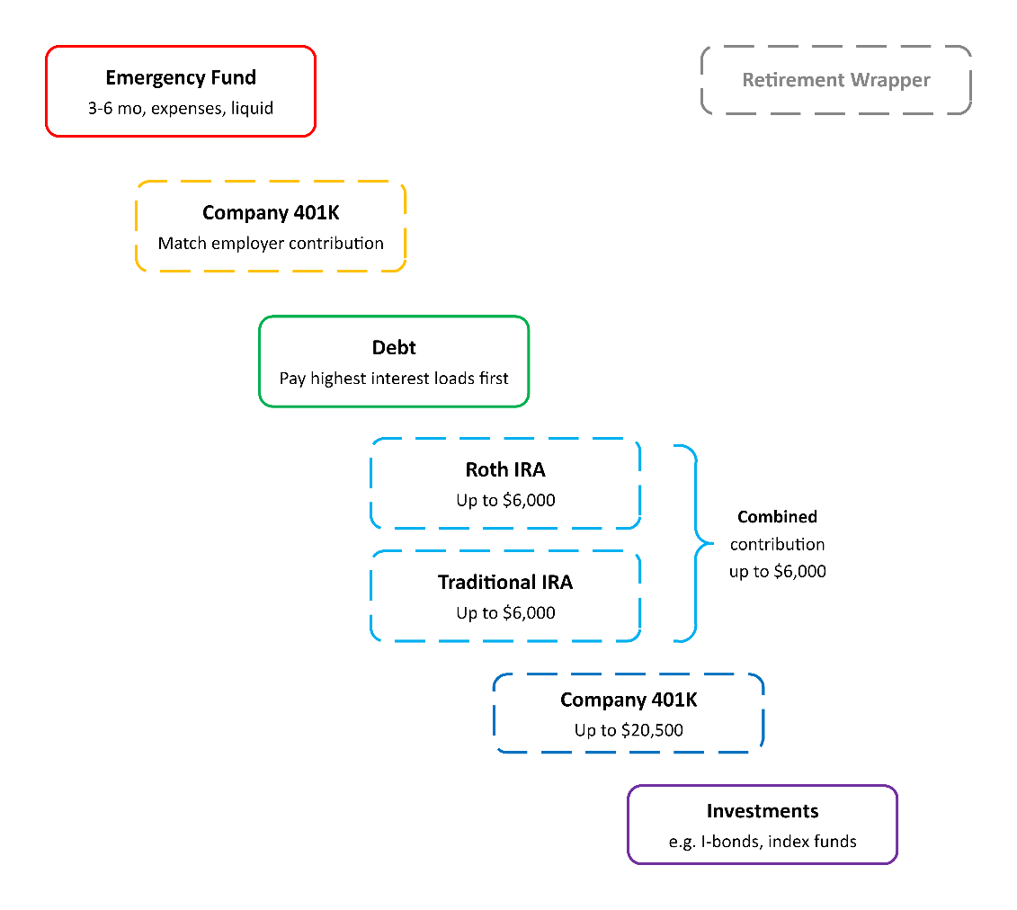

Figure 1 Conceptual Model of Budget System Workflow

# 

Figure 2 Budget Categorization and Limit Structure

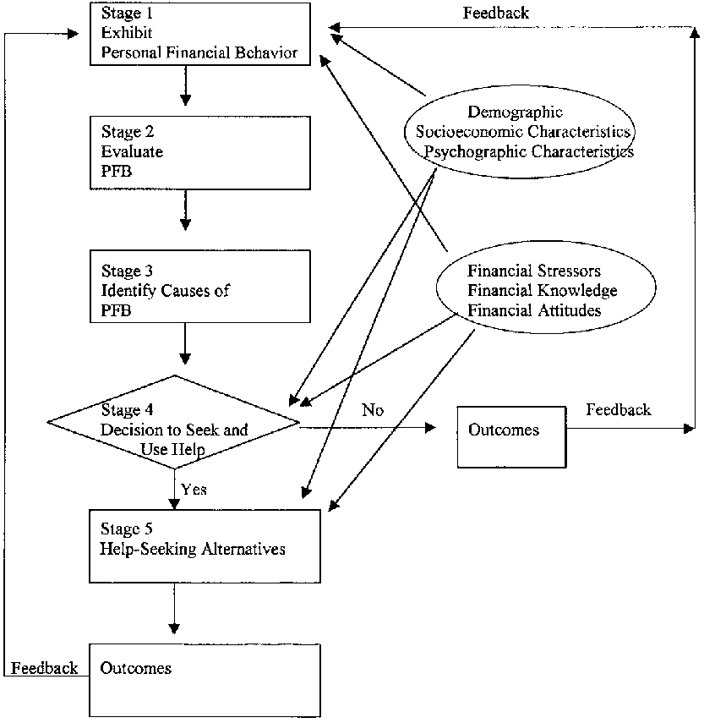

Figure 3 Threshold Alert Decision Flowchart

# **CHAPTER 5 SYSTEM IMPLEMENTATION AND TESTING**

# **5.0 Software Testing Strategy**

Testing encompassed **unit testing**, **integration testing**, **usability testing**, and **regression testing**.

# **5.1 Unit Testing**

Individual functions were tested: database connection logic, form validation, secure password hashing, CRUD operations for transactions and budgets.

# **5.2 Integration Testing**

End-to-end workflows were validated:

user registration → login → adding transactions → viewing alerts → updating budgets → session persistence.

**5.3 Usability Testing**

Participants rated the interface on clarity and ease of navigation. Adjustments were made to button labels, form instructions, and feedback messages.

# **5.4 Regression Testing**

Updates to budgets or settings were confirmed not to disrupt other components or data integrity.

# **CHAPTER 6 CONCLUSION AND RECOMMENDATIONS**

# **Conclusion**

The system successfully met the project objectives. Users could track transactions, set budgets, receive alerts, and the admin panel supported system-wide oversight. User feedback indicated increased budgeting awareness and satisfaction with alert-driven guidance.

# **Recommendations**

Future enhancements might include:

* Email or SMS alerts for budget threshold breaches
* A React Native mobile app version
* Integration with M‑Pesa APIs for automatic transaction imports

# **Further Studies**

Longitudinal research could assess the app’s long-term impact on behavior and explore multi-currency and budgeting flexibility for broader demographics.

# **APPENDIX 1: SURVEY QUESTIONNAIRE**

(Structured set of questions about budgeting behavior, income patterns, and app expectations)

# **APPENDIX 2: INTERVIEW GUIDE**

(Semi-structured interview topics used in qualitative design phase)

# **REFERENCES**

Includes FinAccess Survey, budgeting theory papers, behavioral finance sources, app usability studies [ResearchGate](https://www.researchgate.net/publication/330817113_A_theory_of_personal_budgeting?utm_source=chatgpt.com)[Georgetown University](https://www.georgetown.edu/news/this-money-habit-can-revolutionize-your-finances/?)swu.edu[IJCRT](https://www.ijcrt.org/papers/IJCRT2405912.pdf?" \t "_blank)[IJRPR](https://ijrpr.com/uploads/V5ISSUE10/IJRPR34444.pdf?utm_source=chatgpt.com" \t "_blank).

# **SCREENSHOTS OF SYSTEM**

* Admin Dashboard (cards and user stats)

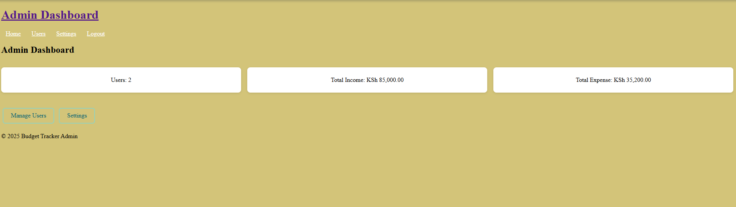

Figure 4 Admin dashboard

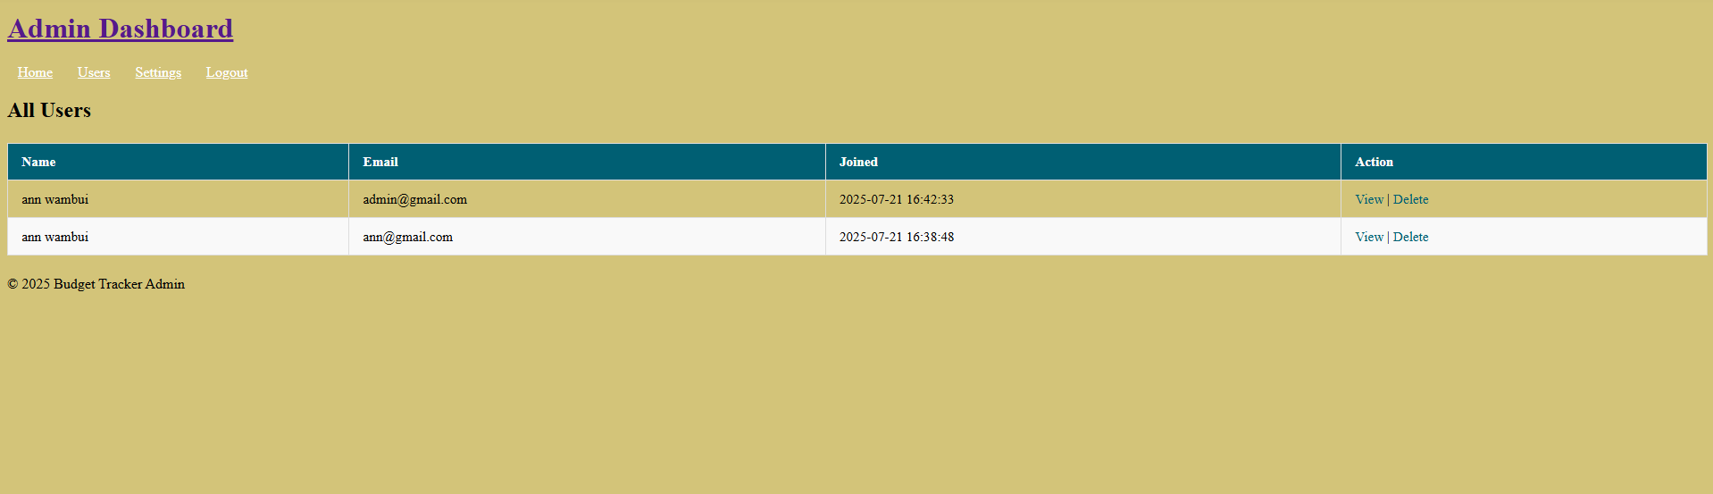

Figure 5 Admin manage users

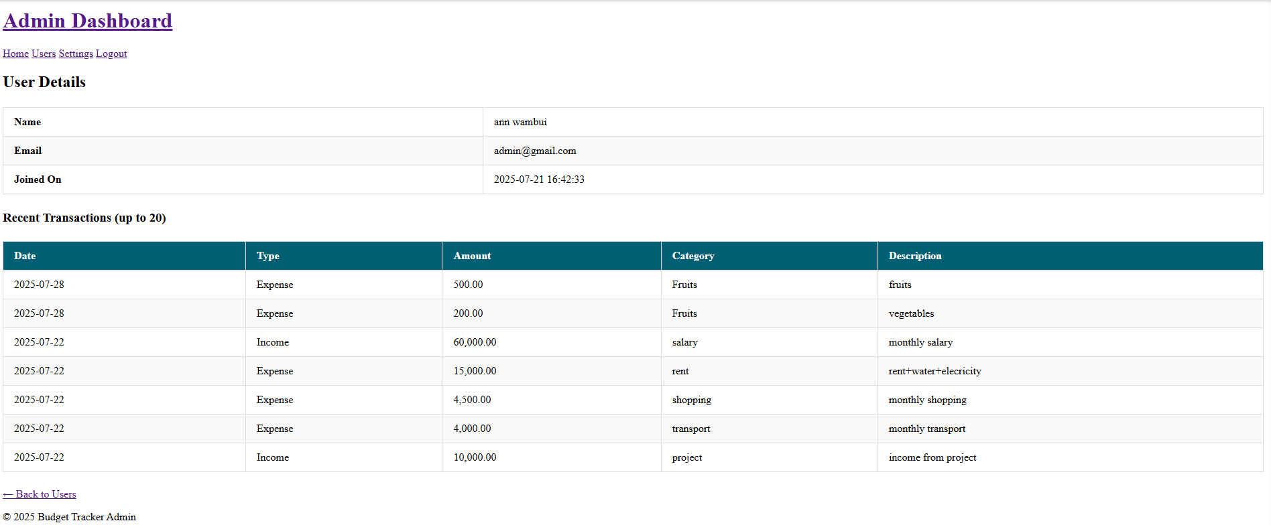

Figure 6 Admin view user

* Manage Budgets Table

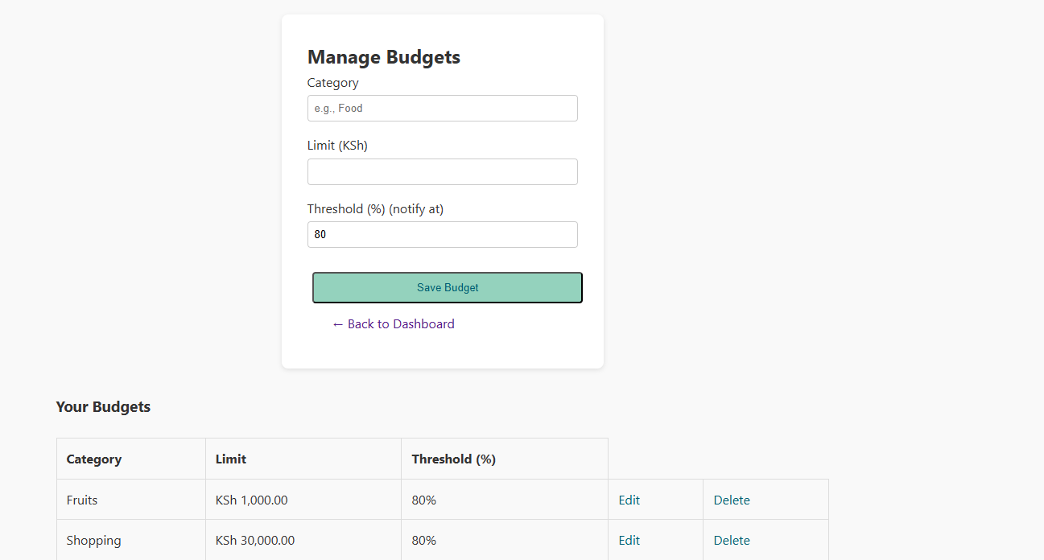

Figure 7 Manage budget

* Edit/Delete budgets interface

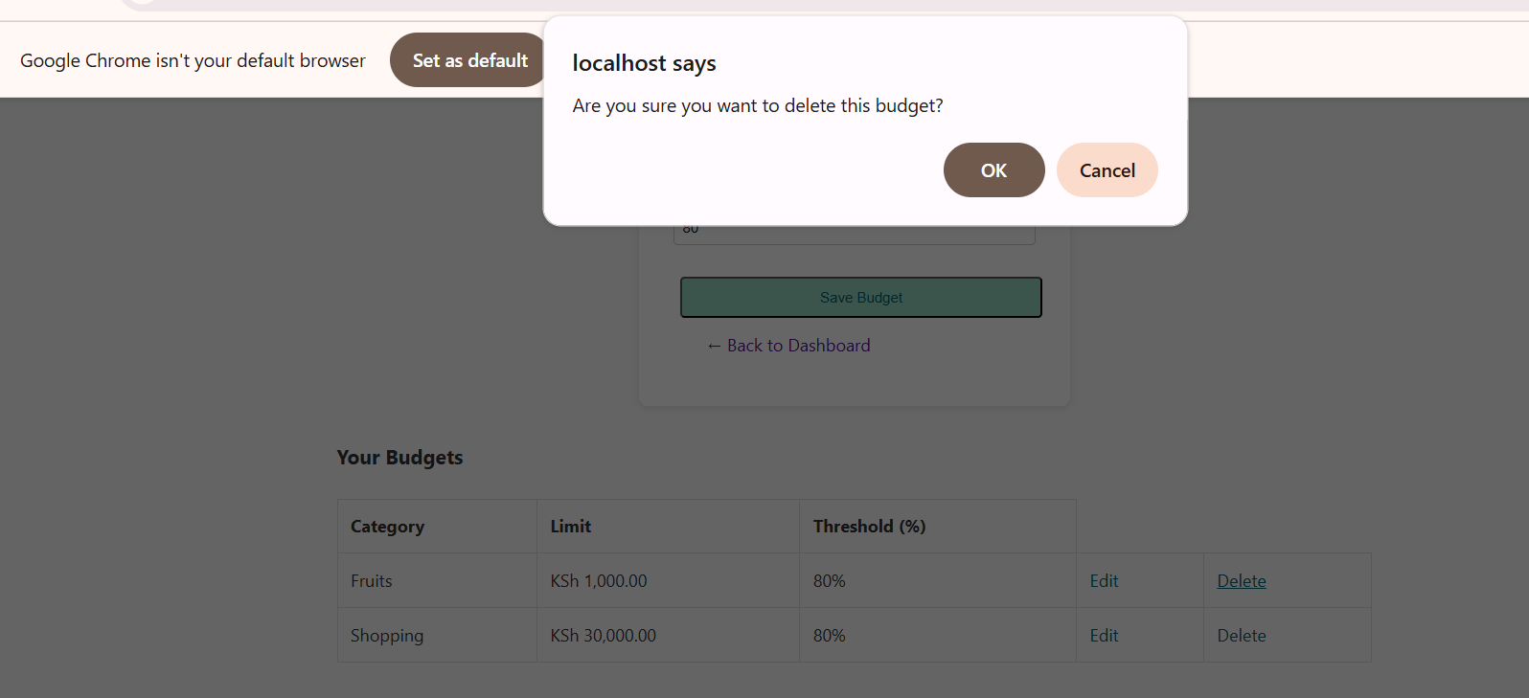

Figure 8 Delete budget

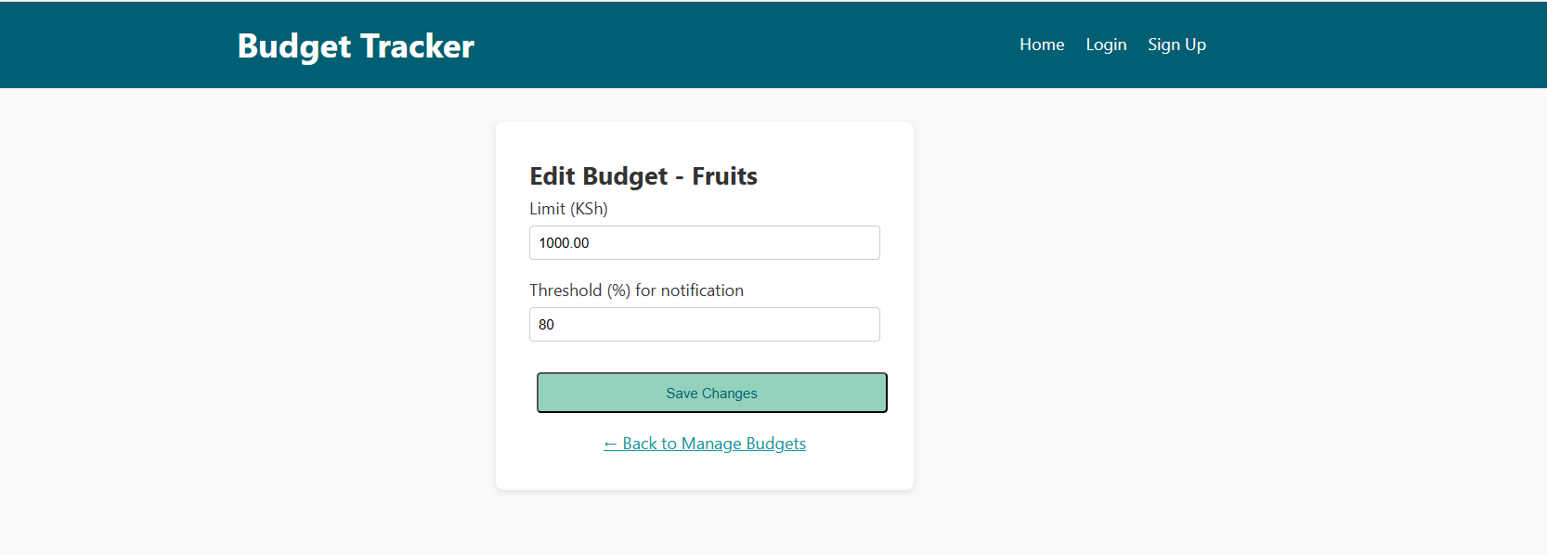

Figure 9 Edit budget

* Settings page

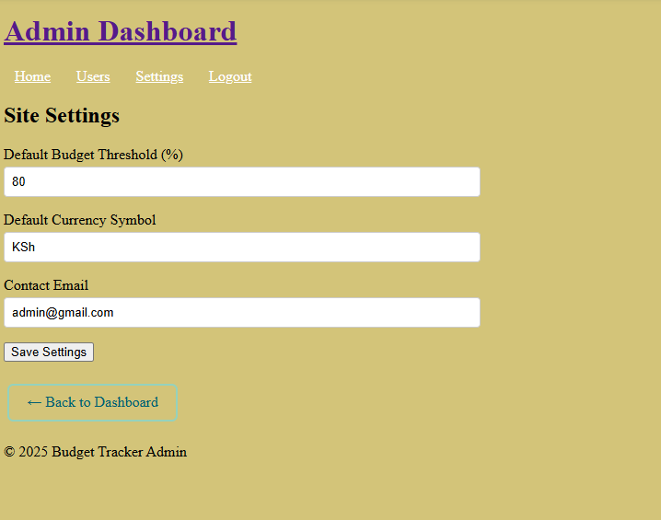

Figure 10 Settings page

* User Dashboard with alerts and summary cards

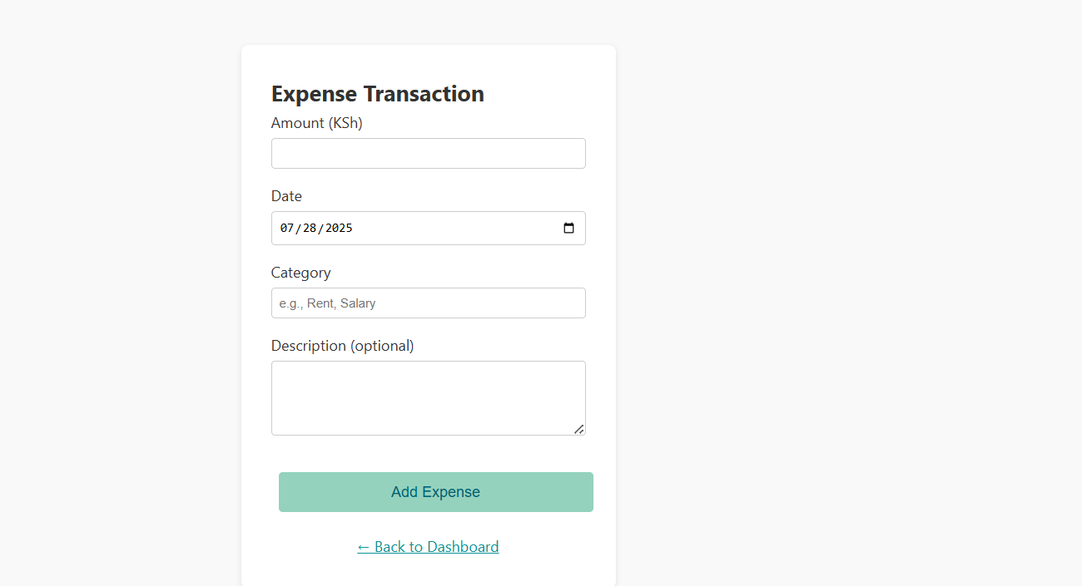

Figure 11 User add expense

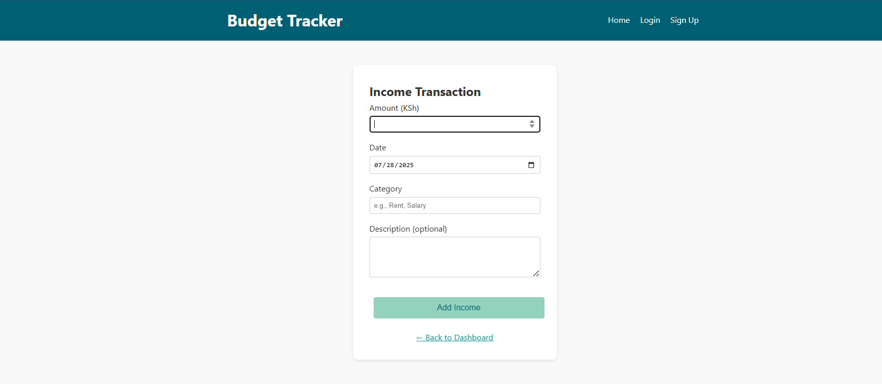

Figure 12 User add income

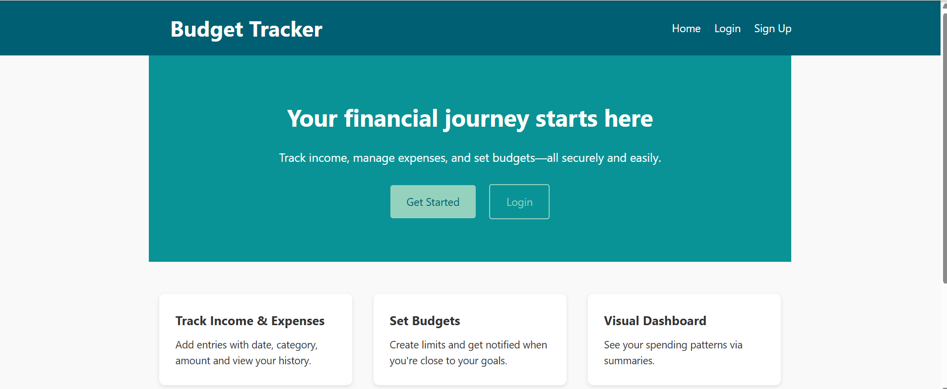

Figure 13 Users home page

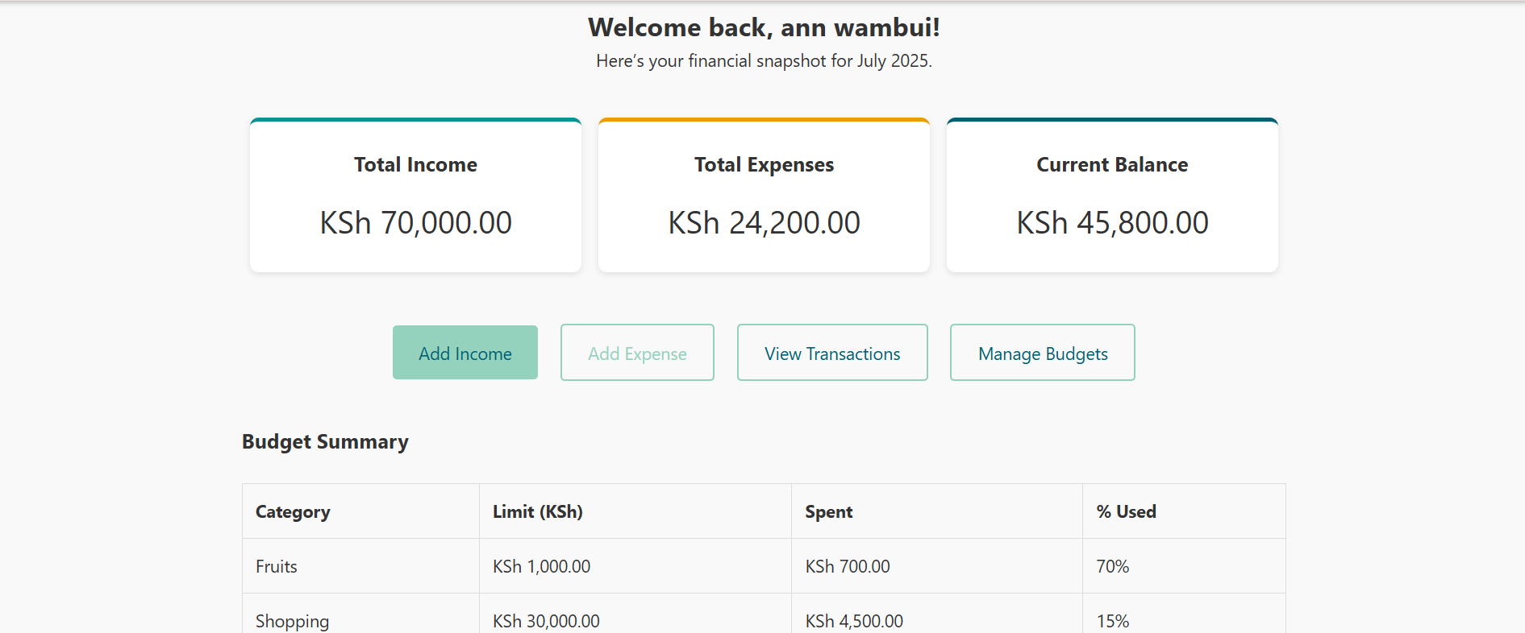

Figure 14 Users Dashboard

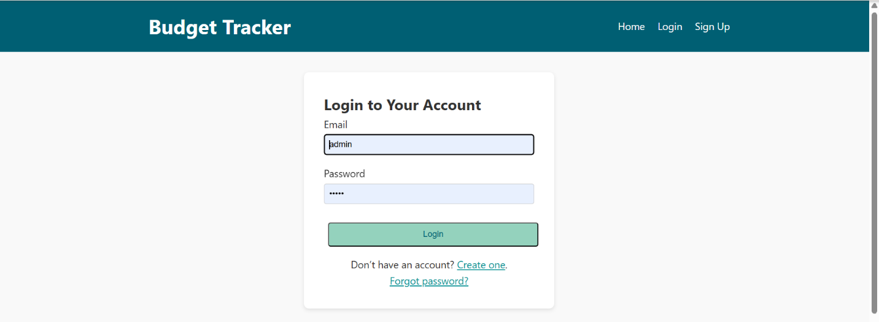

Figure 15 User login page

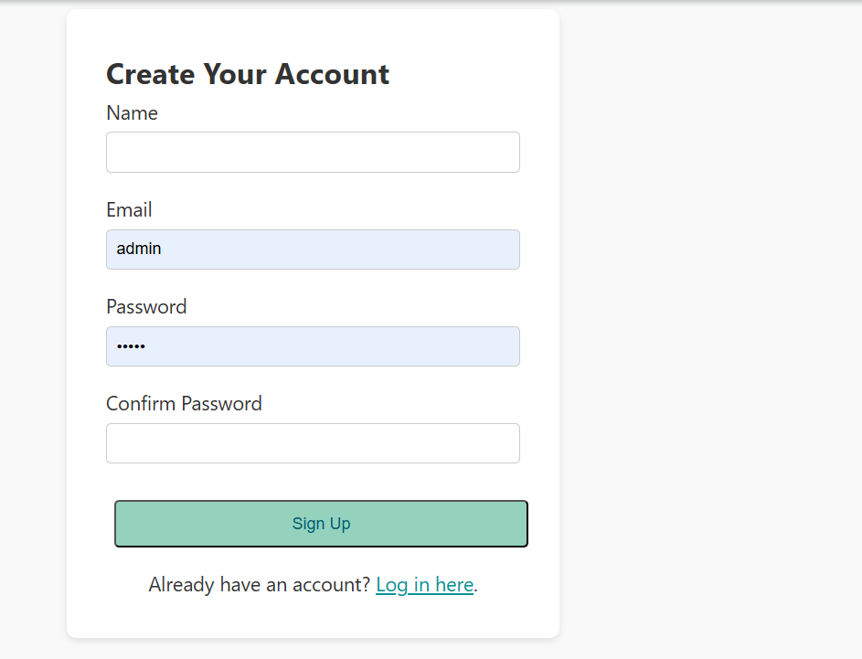

Figure 16 Users Signup page

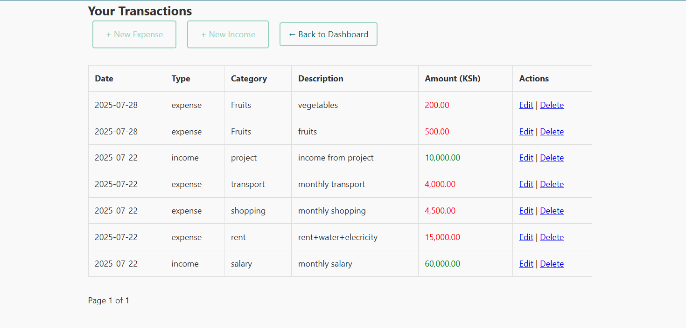

Figure 17 Users view transactions

# **TABLE OF FIGURES**

[Figure 1 Conceptual Model of Budget System Workflow 11](#_Toc204599234)

[Figure 2 Budget Categorization and Limit Structure 12](#_Toc204599235)

[Figure 3 Threshold Alert Decision Flowchart 13](#_Toc204599236)

[Figure 4 Admin dashboard 16](#_Toc204599237)

[Figure 5 Admin manage users 17](#_Toc204599238)

[Figure 6 Admin view user 17](#_Toc204599239)

[Figure 7 Manage budget 18](#_Toc204599240)

[Figure 8 Delete budget 18](#_Toc204599241)

[Figure 9 Edit budget 19](#_Toc204599242)

[Figure 10 Settings page 19](#_Toc204599243)

[Figure 11 User add expense 20](#_Toc204599244)

[Figure 12 User add income 20](#_Toc204599245)

[Figure 13 Users home page 21](#_Toc204599246)

[Figure 14 Users Dashboard 21](#_Toc204599247)

[Figure 15 User login page 22](#_Toc204599248)

[Figure 16 Users Signup page 23](#_Toc204599249)

[Figure 17 Users view transactions 24](#_Toc204599250)